Title
by

Your Name
A Thesis/Dissertation
Submitted to the
Graduate Faculty
of
George Mason University
in Partial Fulfillment of
The Requirements for the Degree
of
Name of Degree, such as Master of Science or Doctor of Philosophy
Academic Discipline for Degree--DO NOT include concentration

Committee:

READ THIS SECTION BEFORE MAKING ANY CHANGES TO IT.
Signature Sheet templates for all colleges and schools (and for degrees/disciplines within the colleges/schools) can be found here:
https://library.gmu.edu/udts/signaturesheets
After you have chosen the appropriate Signature Sheet template for your college/school/discipline, please copy the text under “Committee:” on that template.
Paste the copied text under “Committee:” here on this page. The new text should replace this text.
If your discipline’s Signature Sheet template does not have any names, real or fake (i.e., Dr. Abcdef Ghijkl,), next to the signature lines under “Committee:”, DO NOT supply names here. This rule applies to the College of Education and Human Development, the College of Humanities and Social Sciences, the College of Visual and Performing Arts, and the School for Conflict Analysis and Resolution.
If your discipline’s Signature Sheet template DOES have names, real or fake, replace those names with the appropriate information.

Title
A Thesis/Dissertation submitted in partial fulfillment of the requirements for the degree of Name of Degree, such as Master of Science or Doctor of Philosophy at George Mason University
by
Your Name
Most Recently Earned Degree – Do Not Include Discipline/Concentration
School from Which You Earned Last Degree, Year You Earned It
Previously Earned Degree – Do Not Include Discipline/Concentration
School from Which You Earned Previous Degree, Year You Earned It
Director: Name of the Head of Your Committee, Committee Head’s Job Title
Committee Head’s Specific Affiliation – NOT “George Mason University”
Season Semester Year
George Mason University
Fairfax, VA

Copyright 2023 Your Name
All Rights Reserved
Dedication
I dedicate this work to . . .
Acknowledgements
I wish to thank my advisor, Dr. Margaret Gunderson, for her guidance and support throughout this process. I also want to thank the members of my committee for their invaluable input and infinite patience: Dr. Harold Goldfarb, Dr. Marian Silver, and Dr. Sara Love-Rabinowitz. Finally, my work would not have been possible without generous grants from the Tyrell Corporation, Renholm Industries, Price & Price, and the Weyland-Yutani Corporation.

Table of Contents
Page
List of Tables vii
List of Figures viii
List of Equations ix
List of Abbreviations and/or Symbols x
Abstract xi
Introduction 1
Manuscript One : Title of Manuscript 2
Abstract 2
A Section Within the First Manuscript 3
A Subsection in the First Manuscript 4
A Subsection in the First Manuscript 5
A sub-subsection in the first manuscript 6
A sub-sub-subsection in the first manuscript 7
Appendices for First Manuscript 8
References for First Manuscript 9
Manuscript Two : Title of Manuscript 10
Abstract 10
A Section in the Second Manuscript 12
A Subsection in the Second Manuscript 12
A Sub-Subsection in the Second Manuscript. 13
Appendices for Second Manuscript 14
References for Second Manuscript 15
Manuscript Three : Title for Third Manuscript 16
Abstract 16
Appendices for Third Manucript 17
References for Third Manuscript 18
Conclusion 19
Optional General Appendices 20
Optional General References 21

List of Tables
Table Page
Table 1.1: Your captions can be as long as you wish, but you do not have to include all of the caption’s text in the List of Tables or List of Figures (although you are welcome to do so if you wish). If you need assistance with this issue, please contact the UDTS Coordinator: udts@gmu.edu. 2
Table 1.2: You are permitted to use color in Tables and Figures. We inserted a Page Break before the caption to prevent it from breaking awkwardly between pages. That is an optional step, and you are not required to do it. Please see Table 2.1 to see the result of NOT inserting a Page Break. 4
Table 1.3: You may have an image of a Table. An image of a Table is still a Table and should be labeled and listed as such. 6
Table 2.1: This Table came from an Excel spreadsheet. 10

List of Figures
Figure Page
Figure 1.1: An example of a library. Please note that Tables and Figures (and their accompanying captions) must be separated from nearby lines of body text by at least 3 single-spaced blank lines above and below. You may have more space, but you may not have less. 5
Figure 2.1: A construction site. Your captions can be as long as you wish, but you do not have to include all of the caption’s text in the List of Tables or List of Figures (although you are welcome to do so if you wish). If you need assistance with this issue, please contact the UDTS Coordinator: udts@gmu.edu. 13

List of Equations
Equation Page
Equation 1 Area 7

List of Abbreviations and/or Symbols
Euro €
Her Majesty's Stationery Office HMSO
Measuring Usability of Systems in Context MUSiC
Pi Π
Royal National Institute for the Blind RNIB
United Kingdom UK

Abstract
Title
Your Name, Choose an item.
George Mason University, 2023
Thesis/Dissertation Director: Dr. Name of the Head of Your Committee

A brief yet comprehensive general abstract for the entire document is required to frame the manuscripts and their related conceptual foundations, methodological stream and/or commonalities in addressing a problem or phenomena. The general abstract will help the reader understand the intent of the broader study(ies), as well as the theoretical frameworks, phenomena and methods. The abstract might also describe the participants or contexts that guide the dissertation and all manuscripts, as well as an overview of the results, findings, conclusions and implications. Each component manuscript also will have an abstract that includes the manuscript-specific problem, methodologies, conclusions, and implications.

Introduction
This chapter is optional. Some students choose to include an Introduction in the beginning of the body of the manuscript-style thesis/dissertation, but it is not required.
A bunch of text that says something profound will soon appear in this document. A bunch of text that says something profound will soon appear in this document. A bunch of text that says something profound will soon appear in this document. A bunch of text that says something profound will soon appear in this document. A bunch of text that says something profound will soon appear in this document.

: Title of Manuscript

Abstract
The first manuscript should be placed here. The format of the material must adhere to University Formatting Guidelines. Each individual manuscript may contain its own abstract.
All text in the document must be black, and it must be readable, but you are welcome to change the way all of the text looks. For example: the fact that the Heading 2 Style is Left-Justified 12Pt Bold Small Caps Times New Roman is completely arbitrary. You can either center or left-justify Headings 2 – 9; you can set them in ALL CAPS, Small Caps, or Title Caps; they can be any size, as long as that size is readable; they can be any font. The appearance of your material is up to your personal preference, or it can match the citation guidelines (e.g., APA, MLA, Chicago, etc.) you are using.

Table 1.1: Your captions can be as long as you wish, but you do not have to include all of the caption’s text in the List of Tables or List of Figures (although you are welcome to do so if you wish). If you need assistance with this issue, please contact the UDTS Coordinator: udts@gmu.edu.

You can also make adjustments to the Body Text style. Currently, Body Text is set at ragged right, with a first-line indent. You may change the Body Text’s font; you may remove the first-line indent; you may fully justify the Body Text. Body text must remain double-spaced, with the following caveats:
Block Quotes: If you are using a style that requires block quotes to be single-spaced, you are permitted to make that change. We have provided a style for that: Block.

You may also single-space numbered lists and bulleted lists.

A Section Within the First Manuscript
Students are welcome to include Tables and Figures in the manuscript. They can be interspersed throughout the manuscript body, grouped at the end of the manuscript’s body, or placed in the Appendix specific to this manuscript.
The numbering convention for Tables and Figures here in the Manuscript-Style Template has been set to restart in each Manuscript (e.g., Table 1.1, Table 1.2, Table 2.1, Figure 2.1, Figure 2.2, and so on). If you would prefer to number the Tables and Figures consecutively (e.g., Table 1, Table 2, Table 3, Figure 1, Figure 2, Figure 3, and so on), please contact the UDTS Coordinator for assistance: udts@gmu.edu.

Table 1.2: You are permitted to use color in Tables and Figures. We inserted a Page Break before the caption to prevent it from breaking awkwardly between pages. That is an optional step, and you are not required to do it. Please see Table 2.1 to see the result of NOT inserting a Page Break.

A Subsection in the First Manuscript
A bunch of text that says something profound will soon appear here. A bunch of text that says something profound will soon appear in this document. A bunch of text that says something profound will soon appear in this document. A bunch of text that says something profound will soon appear in this document.

Figure 1.1: An example of a library. Please note that Tables and Figures (and their accompanying captions) must be separated from nearby lines of body text by at least 3 single-spaced blank lines above and below. You may have more space, but you may not have less.

A Subsection in the First Manuscript
A bunch of text that says something profound will soon appear here. A bunch of text that says something profound will soon appear in this document. A bunch of text that says something profound will soon appear in this document. A bunch of text that says something profound will soon appear in this document. A bunch of text that says something profound will soon appear here. A bunch of text that says something profound will soon appear in this document. A bunch of text that says something profound will soon appear in this document. A bunch of text that says something profound will soon appear in this document.
A bunch of text that says something profound will soon appear here. A bunch of text that says something profound will soon appear in this document. A bunch of text that says something profound will soon appear in this document. A bunch of text that says something profound will soon appear in this document.

Table 1.3: You may have an image of a Table. An image of a Table is still a Table and should be labeled and listed as such.

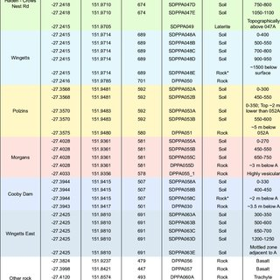
Note: From https://www.researchgate.net/publication/362277971_Geochemistry_of_rocks_and_soils_associated_with_the_Cooby_Trachyte_Member_in_the_Crows_Nest_region_southeast_Queensland

A sub-subsection in the first manuscript. A bunch of text that says something profound will soon appear here. A bunch of text that says something profound will soon appear in this document. A bunch of text that says something profound will soon appear in this document. A bunch of text that says something profound will soon appear in this document. A bunch of text that says something profound will soon appear in this document.
A sub-sub-subsection in the first manuscript. A bunch of text that says something profound will soon appear in this document. A bunch of text that says something profound will soon appear in this document. A bunch of text that says something profound will soon appear in this document. A bunch of text that says something profound will soon appear in this document. A bunch of text that says something profound will soon appear in this document.

Appendices for First Manuscript
Students are welcome to include an appendix/appendices for each manuscript, but the appendix/appendices are not required.. Students may include as many appendices as necessary, and there is no naming convention for them; that is up to the individual student.
Each new Appendix in the manuscript must begin on a new page. The heading for each new appendix should be set in the style “MSHeading.”
All material in Appendices must remain within the margins, but other material (text, images, etc.) has a wider latitude. Further information can be found in the University Formatting Guidelines, and you can contact the UDTS Coordinator (udts@gmu.edu) if you have questions or need any further information.

References for First Manuscript
The references/bibliography for each manuscript must begin on a new page. The heading should be set in the style “MSHeading.” Students may use any citation guide (e.g., APA, MLA, Chicago, IEEE, etc.) for the citations and references in the document.

: Title of Manuscript

Abstract
The second manuscript should be placed here. The format of the material must adhere to University Formatting Guidelines. Each individual manuscript may contain its own abstract.
Students are welcome to include Tables and Figures in the manuscripts. They can be interspersed throughout the manuscript body, grouped at the end of the manuscript’s body, or placed in the Appendix specific to this manuscript. A bunch of text that says something profound will soon appear here. A bunch of text that says something profound will soon appear in this document. A bunch of text that says something profound will soon appear in this document. A bunch of text that says something profound will soon appear in this document.
A bunch of text that says something profound will soon appear in this document. A bunch of text that says something profound will soon appear in this document. A bunch of text that says something profound will soon appear in this document. A bunch of text that says something profound will soon appear in this document. A bunch of text that says something profound will soon appear in this document.

Table 2.1: This Table came from an Excel spreadsheet.
Psych | 11/11/2022 | 1/18/2023 | Yes | 1/16/2023 | 11/22/2022
Edu | 12/2/2022 | 1/6/2023 | Yes | 1/5/2023 | 1/6/2023
ESPP | 8/18/2022 | 8/29/2022 | Yes | 8/17/2022 | 8/29/2022
Edu | 11/7/2022 | 11/18/2022 | Yes | 11/16/2022 | 11/18/2022
PubPol | 11/18/2022 | 11/22/2022 | Yes
Edu | 1/23/2023 | 1/31/2023 | Yes
BioEng | 12/5/2022 | 1/6/2023 | Yes | 12/9/2022 | 1/6/2023
BioInfo | 10/14/2022 | 1/6/2023 | Yes | 12/14/2022
PubPol | 1/17/2023 | 1/19/2023 | Yes | 1/19/2023 | 1/19/2023
CSI | 1/3/2023 | 1/13/2023 | Yes | 1/10/2023 | 1/13/2023
Bio | 10/20/2022 | 11/30/2022 | Yes | 1/3/2022 | 11/30/2022
BioSci | 1/9/2023 | 1/13/2023 | Yes
PubPol | 4/19/2022 | 4/27/2022 | Yes | 4/25/2022 | 4/27/2022
Bio | 11/21/2022 | 11/27/2022 | Yes
IT | 11/22/2022 | 1/19/2023 | Yes | 1/17/2023 | 1/13/2023
ESP | 11/28/2022 | 1/20/2023 | Yes | 1/20/2023 | 1/20/2023
CAR | 1/24/2023 | 1/31/2023 | Yes
BioInfo | 10/20/2022 | 11/30/2022 | Yes | 11/29/2022 | 11/30/2022

A Section in the Second Manuscript
A bunch of text that says something profound will soon appear here. A bunch of text that says something profound will soon appear in this document. A bunch of text that says something profound will soon appear in this document. A bunch of text that says something profound will soon appear in this document. A bunch of text that says something profound will soon appear in this document.

A Subsection in the Second Manuscript
A bunch of text that says something profound will soon appear in this document. A bunch of text that says something profound will soon appear in this document. A bunch of text that says something profound will soon appear in this document. A bunch of text that says something profound will soon appear in this document. A bunch of text that says something profound will soon appear in this document. A bunch of text that says something profound will soon appear in this document. A bunch of text that says something profound will soon appear in this document.
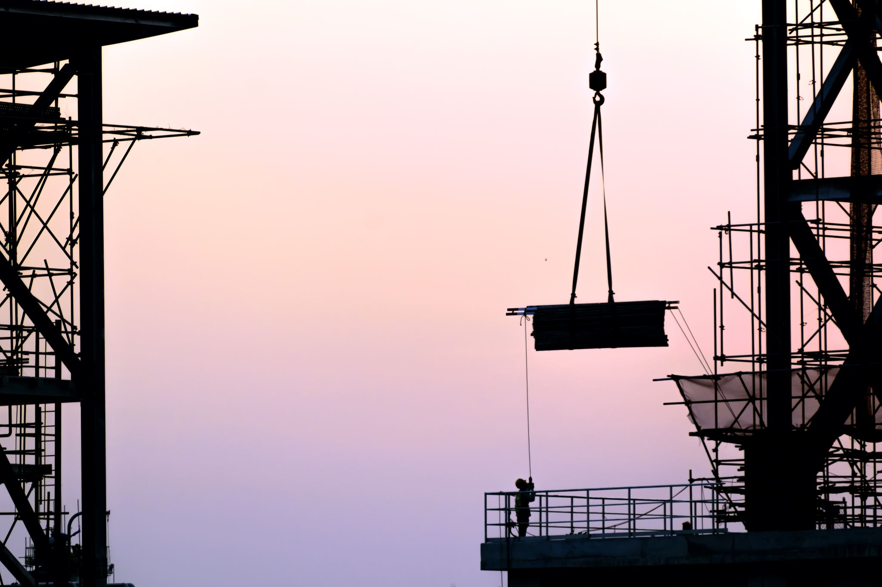
Figure 2.1: A construction site. Your captions can be as long as you wish, but you do not have to include all of the caption’s text in the List of Tables or List of Figures (although you are welcome to do so if you wish). If you need assistance with this issue, please contact the UDTS Coordinator: udts@gmu.edu.

A Sub-Subsection in the Second Manuscript. A bunch of text that says something profound will soon appear in this document. A bunch of text that says something profound will soon appear in this document. A bunch of text that says something profound will soon appear in this document. A bunch of text that says something profound will soon appear in this document. A bunch of text that says something profound will soon appear in this document.

Appendices for Second Manuscript
Students are welcome to include an appendix/appendices for each manuscript, but the appendix/appendices are not required.. Students may include as many appendices as necessary, and there is no naming convention for them; that is up to the individual student.
Each new Appendix in the manuscript must begin on a new page. The heading for each new appendix should be set in the style “MSHeading.”
All material in Appendices must remain within the margins, but other material (text, images, etc.) has a wider latitude. Further information can be found in the University Formatting Guidelines, and you can contact the UDTS Coordinator (udts@gmu.edu) if you have questions or need any further information.

References for Second Manuscript
The references/bibliography for each manuscript must begin on a new page. The heading should be set in the style “MSHeading.” Students may use any citation guide (e.g., APA, MLA, Chicago, IEEE, etc.) for the citations and references in the document.

: Title for Third Manuscript

Abstract
A bunch of text that says something profound will soon appear in this document. A bunch of text that says something profound will soon appear in this document. A bunch of text that says something profound will soon appear in this document. A bunch of text that says something profound will soon appear in this document. A bunch of text that says something profound will soon appear in this document.

Appendices for Third Manucript
Students are welcome to include an appendix/appendices for each manuscript, but the appendix/appendices are not required.. Students may include as many appendices as necessary, and there is no naming convention for them; that is up to the individual student.
Each new Appendix in the manuscript must begin on a new page. The heading for each new appendix should be set in the style “MSHeading.”
All material in Appendices must remain within the margins, but other material (text, images, etc.) has a wider latitude. Further information can be found in the University Formatting Guidelines, and you can contact the UDTS Coordinator (udts@gmu.edu) if you have questions or need any further information.

References for Third Manuscript
The references/bibliography for each manuscript must begin on a new page. The heading should be set in the style “MSHeading.” Students may use any citation guide (e.g., APA, MLA, Chicago, IEEE, etc.) for the citations and references in the document.

Conclusion
This chapter is optional. Some students choose to include a Conclusion at the end of the body of the manuscript-style thesis/dissertation, but it is not required.
A bunch of text that says something profound will soon appear in this document. A bunch of text that says something profound will soon appear in this document. A bunch of text that says something profound will soon appear in this document. A bunch of text that says something profound will soon appear in this document. A bunch of text that says something profound will soon appear in this document.

Optional General Appendices
Appendix Title Here

Optional General References
Alliance for Excellent Education. (2012). Culture shift: Teaching in a learner centered environment empowered by digital learning. Retrieved from the Alliance for Excellent Education website http://www.all4ed.org/files/CultureShift.pdf

Abrams, L. M., Pedulla, J. J., & Madaus, G. F. (2003). Views from the classroom: Teachers’ opinions of statewide testing programs. Theory Into Practice, 42(1), 18–29. https://doi.org/10.1207/s15430421tip4201_4

Au, W. (2007). High stakes testing and curricular control: A qualitative metasynthesis. Educational Researcher, 36, 258–267. https://doi.org/10.3102/0013189X07306523

Berry, B., & Eckert, J. (2012). Creating teacher incentives for school excellence and equity. Retrieved from the National Education Policy Center website http://nepc.colorado.edu/editorial-board

Billingsley, B. S. (1993). Teacher retention and attrition in special and general education: A critical review of the literature. The Journal of Special Education, 27, 137–174. https://doi.org/10.1177/002246699302700202

Creswell, J. W. (2013). Qualitative inquiry and research design. Sage.

Kersaint, G., Lewis, J., Potter, R., & Meisels, G. (2007). Why teachers leave: Factors that influence retention and resignation. Teaching and Teacher Education, 23, 775–794. https://doi.org/10.1016/j.tate.2005.12.004

Lamonte, K. M. (2011). Examining the factors involved in a teacher’s decision to remain in the teaching profession. Retrieved from ProQuest Digital Dissertations. (AAT 9102569)

Biography
Your Name received her Bachelor of Arts in Sociology from Louisiana State University in 2011, then went on to Boston College to receive her Master of Science in Biology. After receiving her Doctor of Philosophy in Public Policy from George Mason University in 2023, she will continue to work for the federal government.

